GOOGLE GEMINI HANDSON
ASSIGNMENT-1

Exercise-1: First Login &amp; Plan Check
Scenario
You are a new Gemini user. Your goal is to log in, identify your current plan, and get comfortable with the interface before doing anything else.
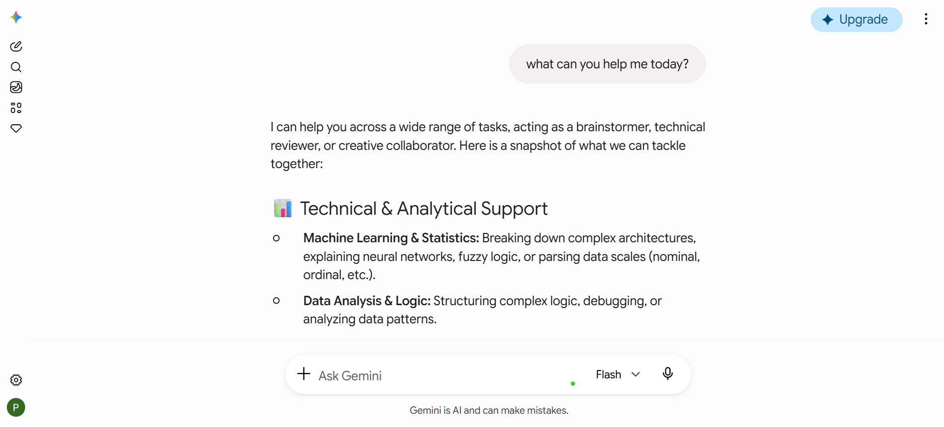
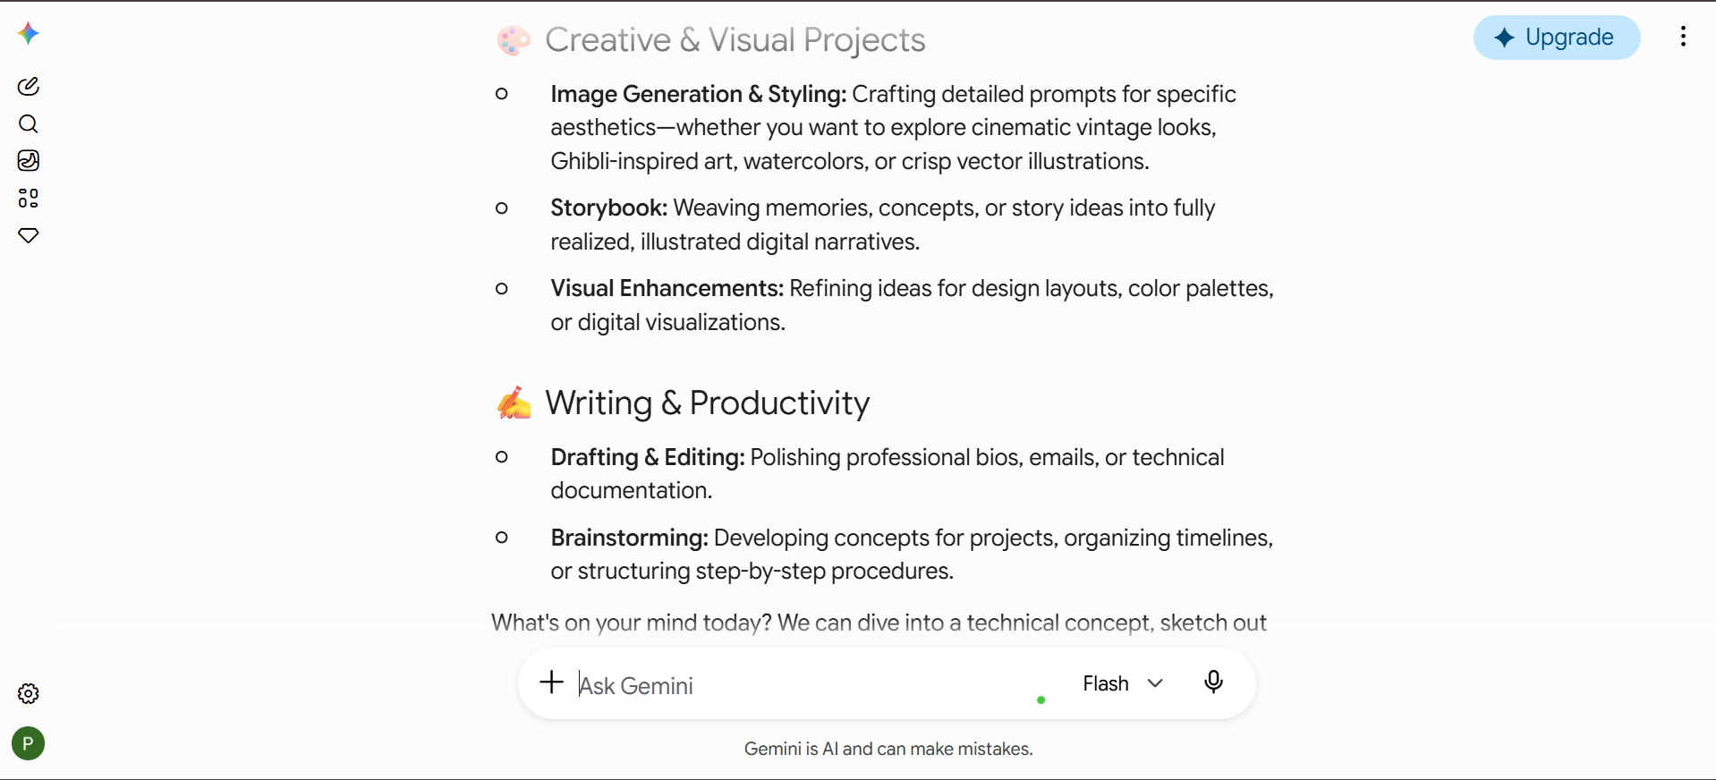
Answer: Succesfully logged in and interacted with the Gemini.

Exercise-2: Set Your Custom Instructions
Scenario
You want Gemini to know you are a small business owner who uses Android and prefers concise, bullet-point answers. You will configure this once so it applies to every future
conversation.
Answer: Custom instructions are set and the gemini is tested imediately. The AI is responding as per the instructions.
Custom Instructions:
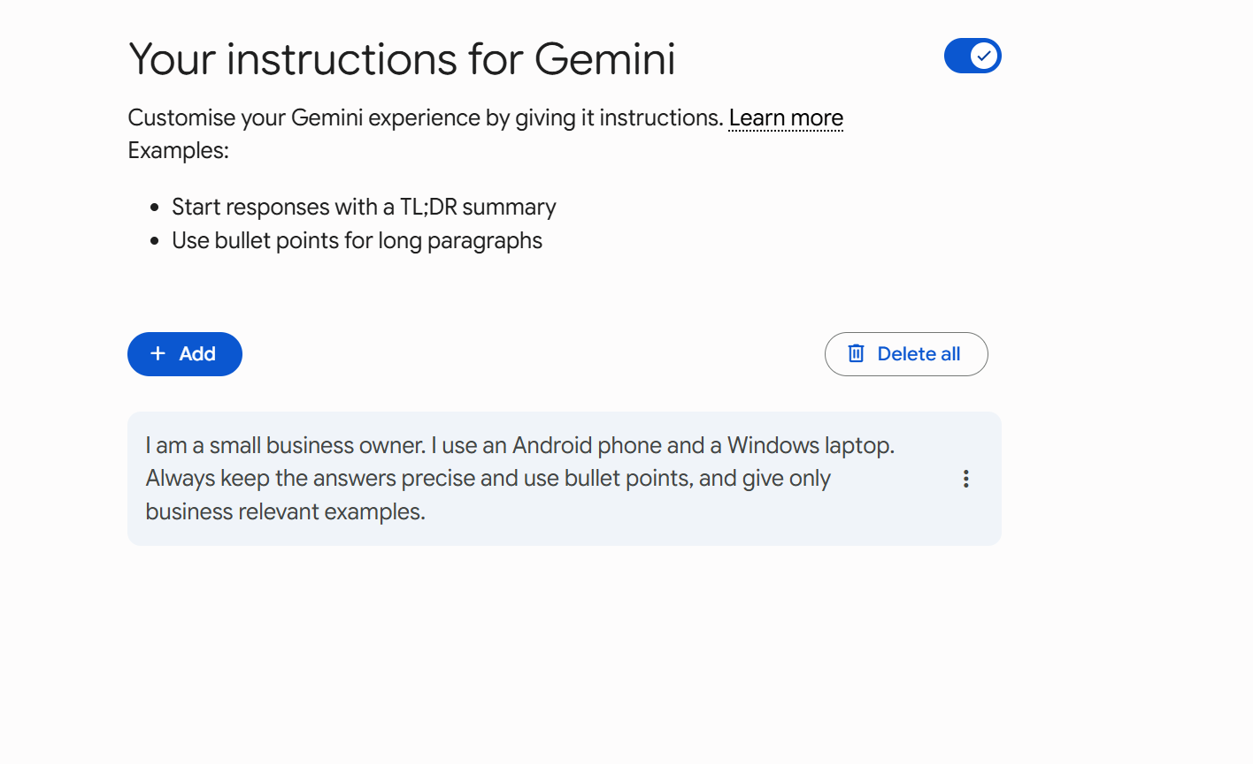

Working as per instructions:
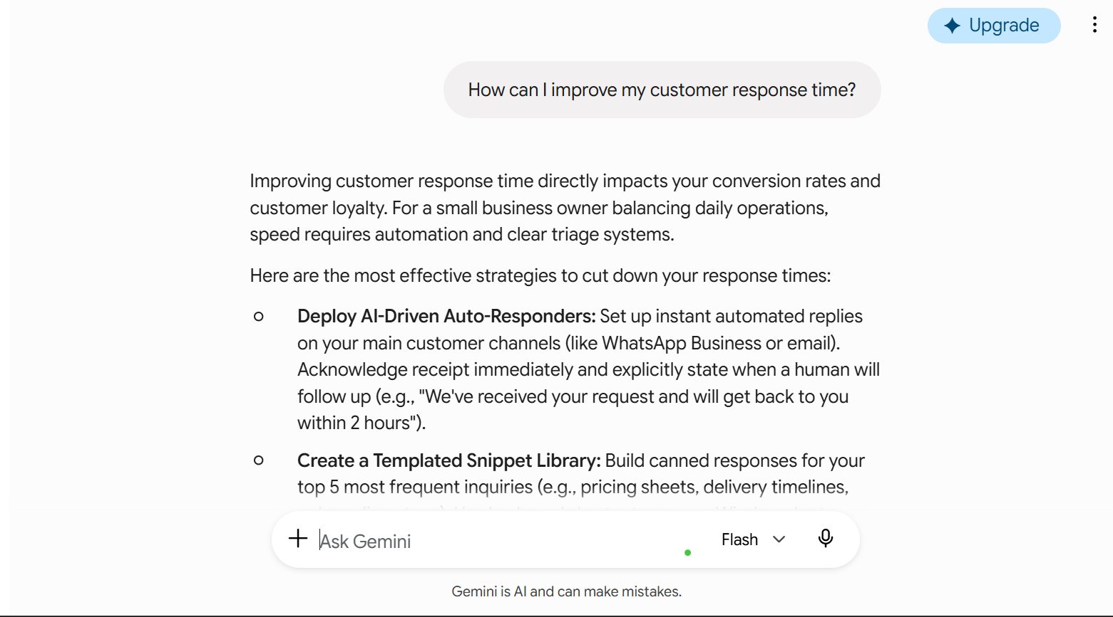

Exercise-3: Normal Chat vs Temporary Chat
Scenario
You want to clearly understand the difference between standard chat (saved history) and
Temporary Chat (incognito mode), and know when to use each.

Answer:
Temporary chat is like a incognito mode in chrome. It is used for health related quesries and for confidential queries.
Permanent chat:
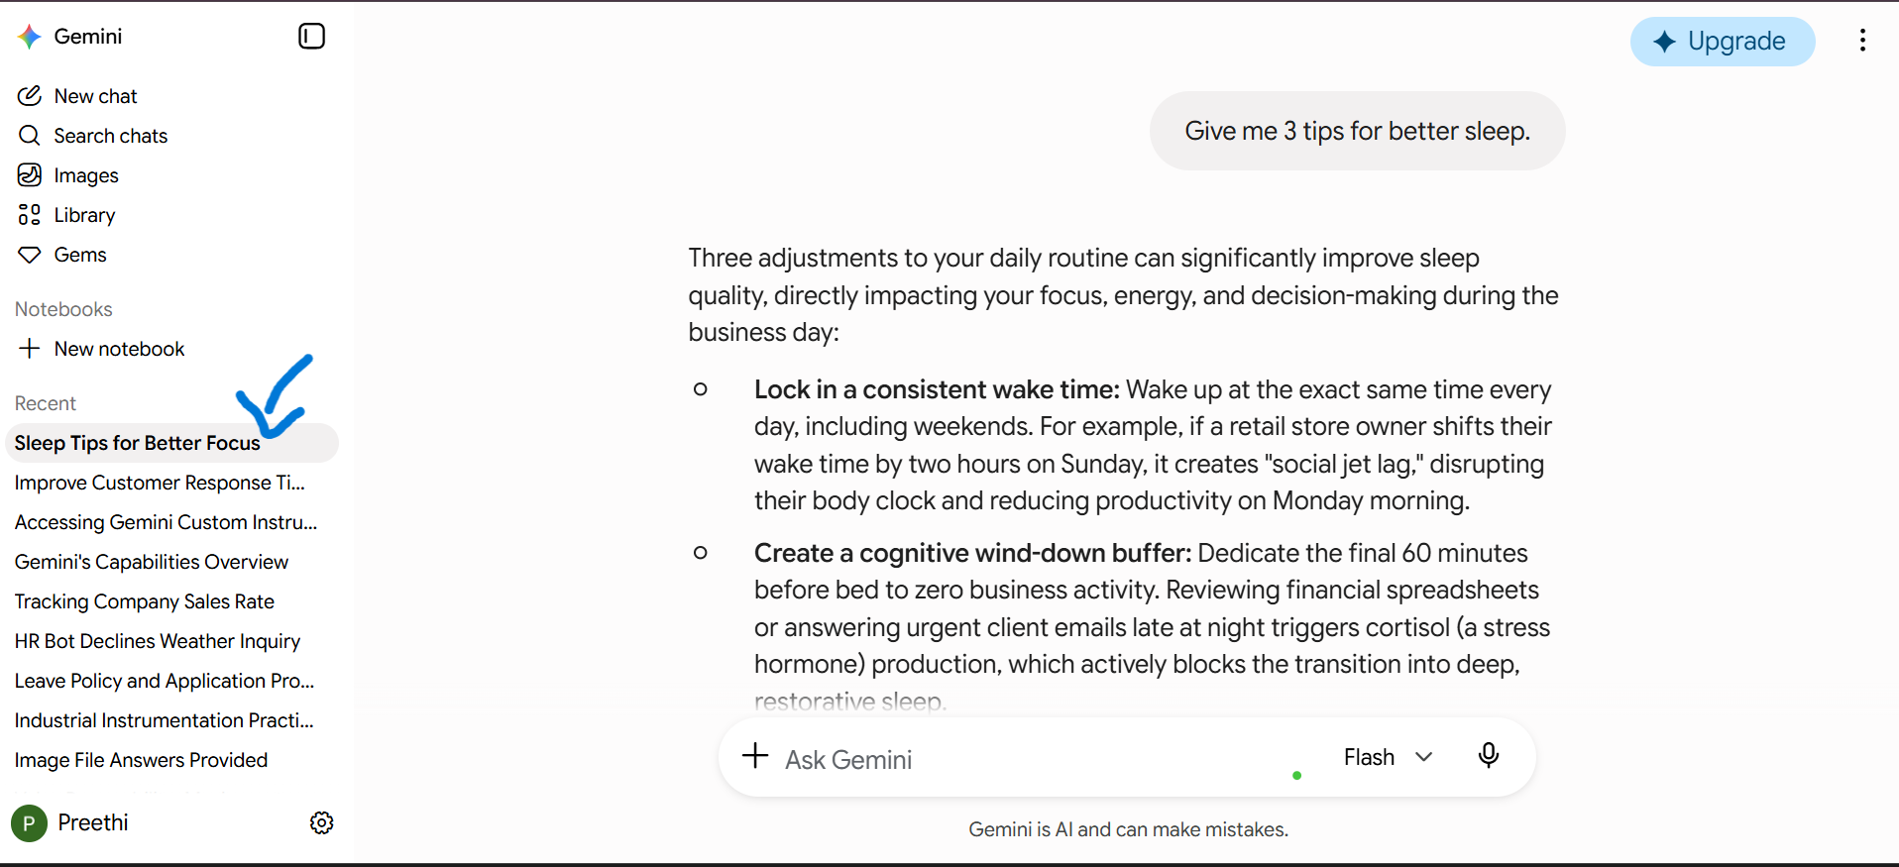

Temporary chat:
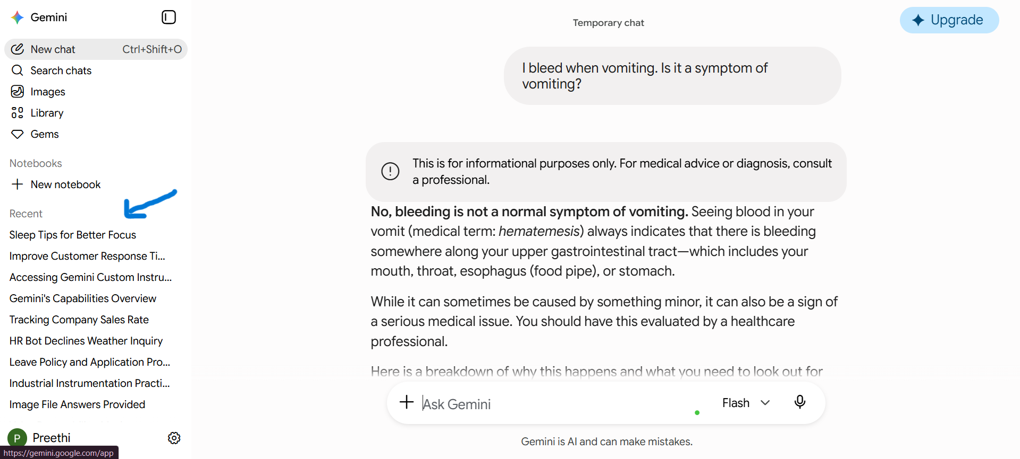
Exercise-4:Edit Your Last Prompt
Scenario
You asked Gemini a question but the response was too long and detailed. Instead of starting a
new chat, you use the prompt editing feature to refine your request.
Answer: The gemini allows the user to edit the prompts to avoid retyping the prompts again.
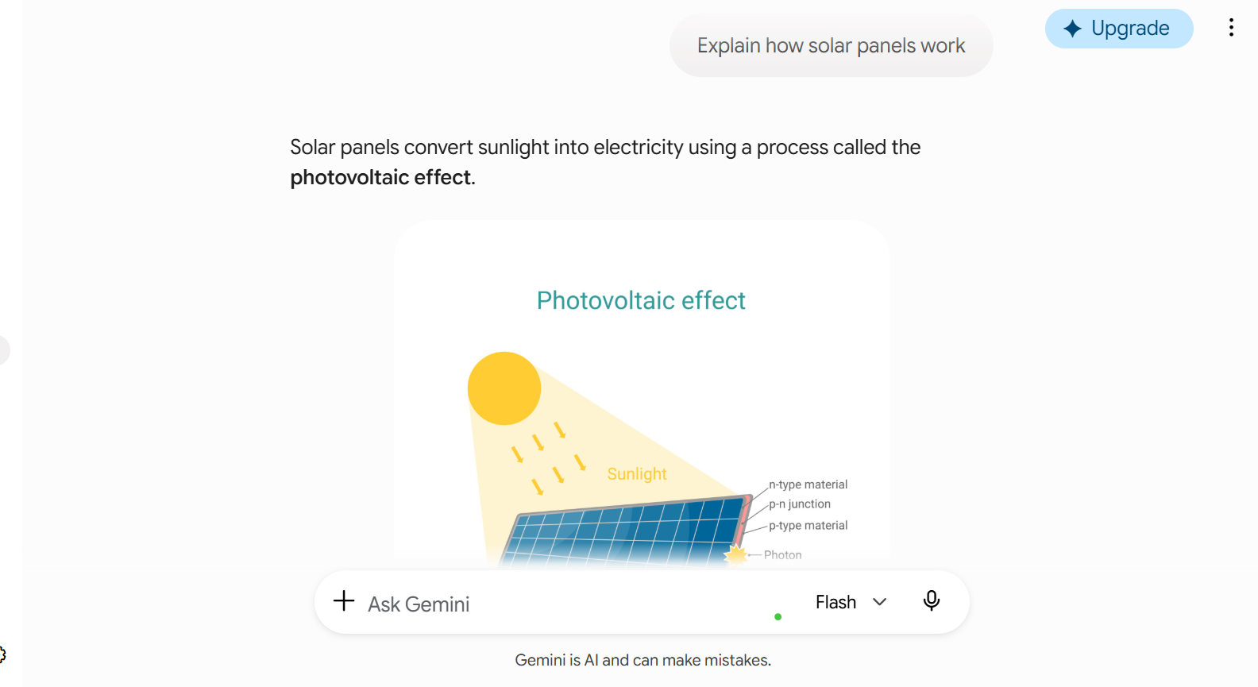
First prompt

Editing the last prompt:
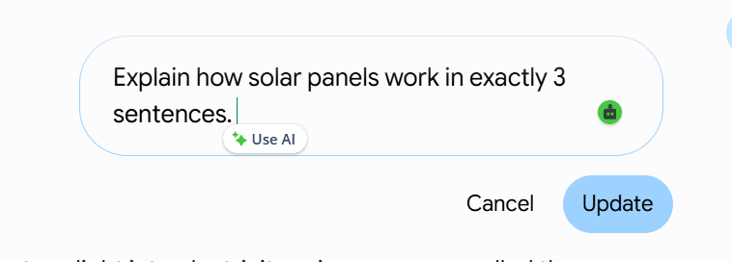

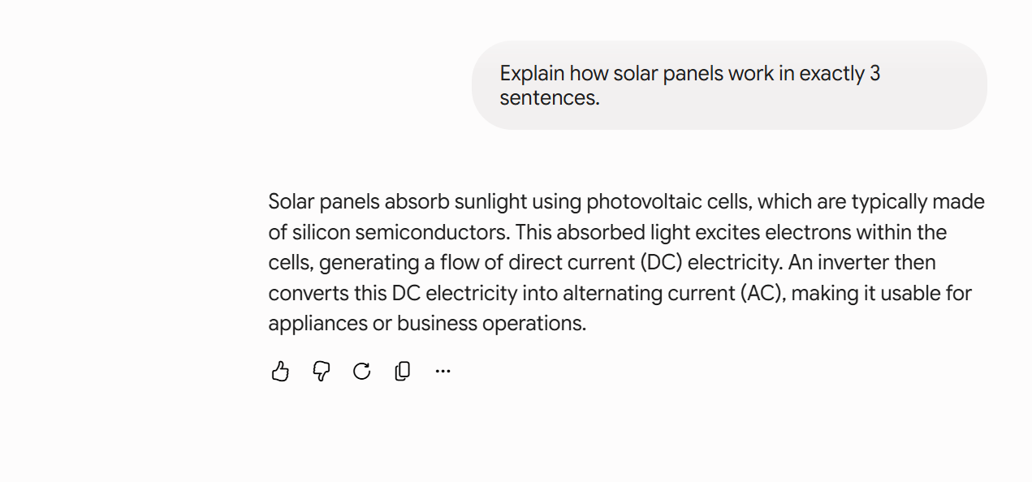
Final edited prompt:

Exercise-5:Connect Google Apps &amp; Ask a Personal Question
Scenario
You want Gemini to act as a true personal assistant by accessing your real Gmail inbox —
demonstrating the difference between a search engine and a personal AI.
Answer: Gemini answered with my personalization.
Google workspace connected:
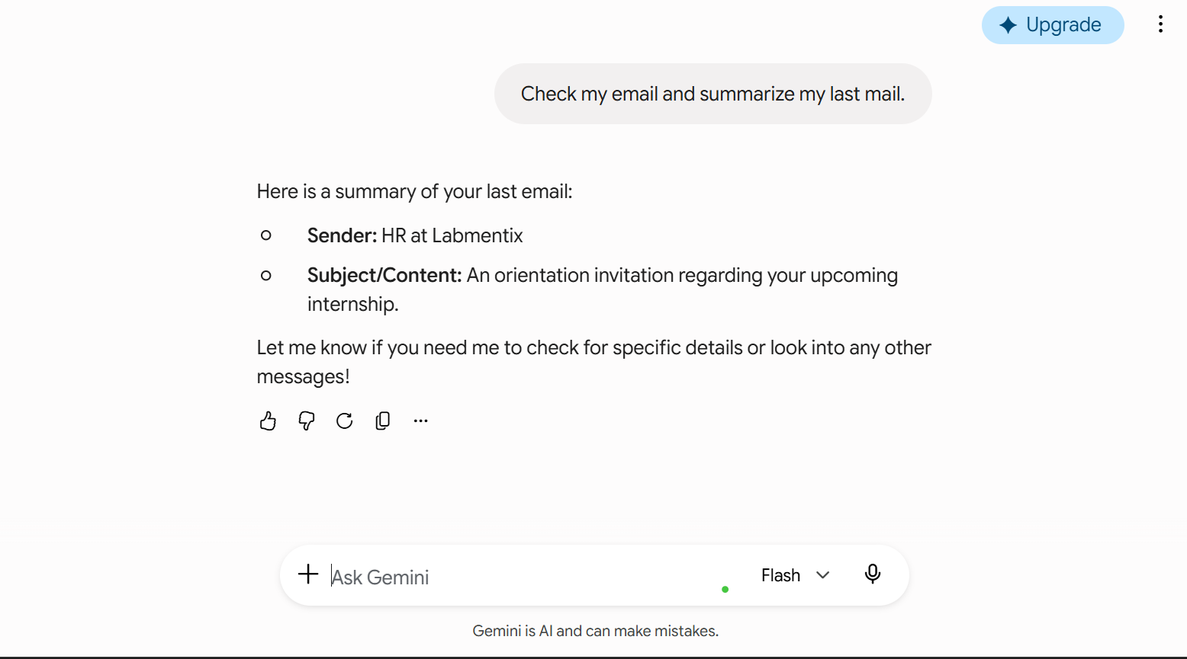
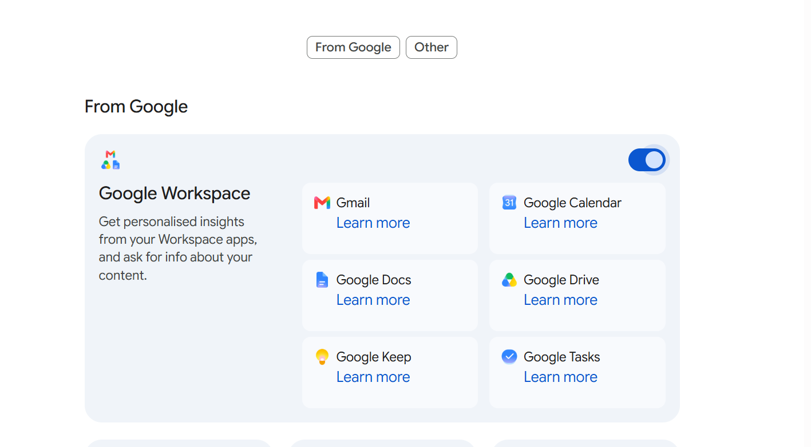
Response:

